**Safety Plan & Event Plan**

**For**

**Aorangi Undulator**

**and**

**Aorangi 100**

6th, 7th and 8th November 2015

Prepared by: The Organising Committee

2014 Aorangi Undulator

Version 2.0

# Version Control

This document has been through the following versions to date:

| Date | Version | Major Changes |
| --- | --- | --- |
| 11 September 2013 | Version 1.0 | Initial document, reflecting the current state of the Safety Management Plan (SMP) and Event Plan for the 2013 Aorangi Undulator |
| 1 June 2015 | Version 2.0 | Revised document to incorporate learnings from trial run of event in 2014 |

This document is managed by the Aorangi Undulator Organising Committee. Modifications should be submitted through to Chris Martin (C.Martin@gns.cri.nz) for document update and publishing.

Version Control 2

1. Safety Management Plans – An Introduction 4

2. Safety Management Plan as documented by the Aorangi Undulator Organising Committee 5

3. Communication 6

3.1 Event Summary 6

2014 Aorangi Undulator 6

Day 1 Course Notes 6

General notes: 6

Day 2 Course Notes 7

General notes: 7

Section 1) Start at Mangatoetoe river to Kawakawa Hut 7

Section 2) Kawakawa Hut to Pararaki Hut 7

Section 3) Pararaki Hut to Washpool Hut 7

Section 4) Washpool Hut to Finish 7

Day 3 Course Notes 7

3.2 Communications 7

General Communications 7

4. Event Plan 9

4.1 Stage Breakdown 9

4.2 Participants Notes 13

Event Rules 13

Event Management 14

4.3 Event Briefing 14

Marshal Briefing 15

5. Event Maps 16

6. Race Terrain 20

7. Entry Form and Disclaimer 27

# Safety Management Plans – An Introduction

The Safety Management Plan (SMP) is all about athlete and community safety, through successful management of event hazards and athlete interaction.

Simply put, the objective of a Safety Management Plan (SMP) is to describe the nature and extent of a hazard at an event site. It describes how event participants and the general public will be able to safely negotiate the area through the use of temporary safety management measures. The SMP shall:

* Describe the hazard that exists, inclusive of location and nature of hazard,
* Detail the hazard management plan that has been prepared to reduce the risk associated with the hazard,
* Be the basis of communication with all interested parties, on the hazards identified and how the risks associated with the hazard are to be mitigated, and
* Be the basis on which approval and acceptance of the hazard risk mitigation plans are granted.

Additionally, the Aorangi Undulator Organising Committee uses the SMP to:

* Communicate to event marshals how their area of marshaling is to be set out and the extent of their roles and responsibilities
* Define the level of information that is to be supplied to event athletes and support crew, by way of event notes and ongoing event information
* Record the hazard management mitigation measures that have been implemented, both for post event review and for feedback into future repetitions of the same event format.

The Safety Management Plan itself is composed and delivered by the Event Organisers and associated event officials. The following individuals have prepared or have contributed to this Readiness Plan:

* Aorangi Undulator Organising Committee
  + Chris Martin
  + Sherman Smith
  + Chris Swallow
  + Thom Charles
* Jo Holden – NZ Police Search and Rescue, Wellington
* Jo Hansen DOC Ranger Aorangi Forset Park 06 377 2196. Jo is helping us with river level consulting and track maintenance.

The Plan is expected to be a ‘living’ document up to the point that the event commences. As such, updates will be made to this document to reflect the decisions made during the SMP approval implementation process. Version changes will be noted in the ‘Version Control’ section at the start of the document.

# Safety Management Plan as documented by the Aorangi Undulator Organising Committee

This SMP is used to assist the Aorangi Undulator Organising Committee in working through the processes required to secure approval for the hazard identification and mitigation planning undertaken.

This document is submitted to all authorities from which SMP approvals are required in order to secure permission for the use of the locations required for the event.

In preparing this SMP, the following areas have been considered and included within this document:

| Sub-Plan | Activity | Purpose and Comment |
| --- | --- | --- |
| Communications | Event Summary | Summarises the event description, disciplines, locations and rules. |
|  | Communications | Reflects all the direct and indirect parties (including stakeholders) involved with the event and describes who is responsible for every aspect of it. |
| Event Plan | Stage Breakdown | Describes each stage, the hazards that exist within the stage, the hazard mitigation factors (inclusive of diagrams where required) and the marshaling plan to be implemented. |
|  | Athlete Notes | Details the information that will be made available to athletes by way of Athlete Event Notes. |
|  | Event Briefing | Details the information that will be made available to athletes at the Athletes Event Briefing on Event day |

This represents the full spectrum of considerations involved with the Event Planning and the SMP.

This means that through the SMP, event officials, interested parties and athletes themselves will be aware of:

* who are the contacts for the event, and for approving / authorising bodies,
* what is the event, how is it structured and where will it be held,
* what are the event sections, and what locations will they cover,
* what are the hazards and how will they be managed,
* what information will be made available to the athlete by way of event notes, and
* what information will be advised to the athlete, by way of event the briefing.

# Communication

## Event Summary

### 2015 Aorangi Undulator

| Event Structure | Details |
| --- | --- |
| Event Dates and Start Time | 7:00am on Friday 6 Sat 7 and Sunday 8 November 2015  Registrations from 6:00am  Day 1 Race Briefing at 6:30am at Muritai Road , Eastbourne. Day 2 6:30am Mangatoetoe Valley Entrance Day 3: 6 30 Pinnacles Car Park |
| Expected Number of Athletes | 30 in 3 day event an extra 100 in 1 day |  |
| Expected Duration of Event | Day 1: 5-10 hours  Day 2:-5-12 hours  Day 3: 4-6 hours |  |

### Day 1 Course Notes

### General notes:

50km run as per map. There are 4 marshals as per the map.

The route follows the coastal track around the first Lake at east Harbour Park and around coast. We have contacted the owners of the private property around Baring Head and gained consent to cross land. However the Ranger Mark McAlpine has suggested that the competitors can run this section without trespassing. Both private blocks that are between Baring Head and the Parangarahu lake come down to the sea but stop 20m above high tide mark. Therefore you can walk along the beach front and you will not be trespassing.

The course turns left inland up the Orongorongo Valley, then right at the base of the Mt Mathews track in the Orongorongo Valley, over the South Saddle and down the Mukumuku Valley, then turns left at the coast and finishes at Corner Creek campsite. The course is well marked up to the South Saddle and down the Mukumuku Valley. There will be additional event marking also. The competitors follow the main Orongorongo river valley.

The course is fairly flat, with the exception of the south saddle, and two test runs have been run both in 6 hours.

If the weather is very bad and river levels are deemed too high we will inform competitors we will cancel by 6pm the night before via their mobile numbers. Conditions will also be assessed on the event morning in the event of inclement weather by a marshal located at the head of the Orongaronga river valley. If the river is deemed to be too high competitors will be sent along the coast instead.

All marshals on Day 1 will have a radio each and a Satellite phone to be in contact with the race organiser who will be based at the edge of Lake Oneke the race finish of day 1. A ferry supplied by Lake Ferry Tavern will be supplying a shuttle service to the Lake Ferry tavern.

We will be in touch with SAR to let them know that the event is taking place.

At the end of Day 1 we meet the competitors at the Lake Ferry pub (a ferry is providinga regular shuttle service from end of race to the pub) and take them to the accommodation at Mangatoetoe valley..

### Day 2 Course Notes

### General notes:

The whole course is a marked DOC track/route, covered the whole way by triangular orange DOC markers and backed up in the less obvious places (such as tree falls / junctions) by orange tape markings.

### 

### Section 1) Start at Mangatoetoe river to Kawakawa Hut

The course follows the river upstream, and then after 4km (approx. 30 mins) the river splits around an island before rejoining further upstream. The course takes the left side. After another 1km (approx. 10mins) the course heads left at a river junction. The course travels up the river, until exiting at a river fork well marked near a cut cabbage tree stump in river. The course then climbs approximately 130 vertical meters steeply up to the saddle and then steeply back down the other side then follows the river downstream. KAWAKAWA HUT is on the true right of river, and marshaled. A 4WD track crosses the river at the hut. Competitors will check in with the marshal before proceeding.

### Section 2) Kawakawa hut to Pararaki Hut

From Kawakawa hut the course heads upstream crossing a creek regularly for 10 to 15 mins and then turns left at ‘Pararaki Hut’ wooden sign. At this point there is a steep climb of approximately 310 vertical meters up a narrow ridge. Competitors will be briefed to take this section with extra care. The course rises up to the saddle then descends to Pararaki river, turns right upstream and the hut Pararaki Hut is 100m upstream on the left

Competitors will check in with the marshal before proceeding.

### Section 3) Pararaki hut to Washpool hut

From Pararaki Hut the course climbs 550 vertical meters then descends steeply ending in final 30 or so meters of loose scree. The course then heads left and down Washpool stream for 100m or so before a wooden sign to the Washpool Hut directs competitors up to the hut. Competitors will check in with the marshal before proceeding.

### Section 4) Washpool Hut to Finish

From Washpool Hut the course follows the well signed Kopi track over another steep 550 vertical meters climb and then follows an obvious left turn towards the NW ridge. The ridge undulates for 3km through beautiful And then descends until the fourth marshal directs competitors left towards the Putangirua Pinnacles The course follows the lookout track and not the ‘Circular Walk’ then descends to the river valley, then follows the river down towards the ocean and finishes at the Putangirua Pinnacles campsite.

### Day 3 Course Notes

Starting at the Putangirua Pinnacles campsite the course follows The Haurangi Crossing a popular MTB route. Please refer to map for the description. There will be one stationary marshal at the base of the descent and also roving marshals on MTB along the track.

## Communications

### General Communications

For general communications, relevant contact points are as follows:

**Aorangi Undulator Organising Committee**

| Name: | Title: | Contact Details: |
| --- | --- | --- |
| Chris Martin | Event Organiser | 0212166436 |
| Farm Owner | Kawakawa Station | 06 3078989 |
| Ranger Jo Hansen | DOC – Masterton Partnerships | 06 377 2196 |
| Gary Foster | Wairarapa LandSAR Contact | 027 295 4916 |

Wairarapa LandSAR will informed of the course and the event dates. I have informed Jo Hansen who is on Wairarapa LandSAR and he is informing them of the race on the LandSAR meeting in Mid August. I let him know we don’t need their help just that we are letting them know the event is on.

Key communications pack will be emailed to competitors ahead of the event

This information will include:

-Event timing, logistics and schedule for each race day.

-Latest weather Update and info on any cancellations, course changes or postponements Such information will also be posted on the event website, blog and facebook page-Safety notes. What to do if lost or injured.

-Maps of the routes with detailed description of the routes.

-How to use the gps trackers we will supply through Follow My Spot GPS tracking.

-GPS of route coordinates suitable for upload with compatible GPS navigation devices. These files are available for download from the event website.

-Water stops and information on where to get water. Hut water and river water has been drunk on numerous occasions by the race committee when trialling the race with no adverse effects.

# Event Plan

## Stage Breakdown

This is the detail section of the SMP. Event stages and hazards, together with hazard mitigation measures, are listed here. Further information may also be attached in the appendices to this document.

This section of the Safety Management Plan (SMP) and Event Plan lists each stage of the event, and details:

* Stage Discipline
* Stage Distance
* Stage Location / Area

For each stage, known hazards are addressed. For each hazard, the following information is presented:

* Hazard Type
* Hazard Location
* Hazard Mitigation Measures
* References to further information

*Event Notes*

Description of the course including:

* Access / Entry points
* Navigation commentary

| Breakdown | Details: |
| --- | --- |
| **Discipline** | Mountain Run |
| **Distance** | Day 1 50km  Day 2 33km.  Day 3 25km |
| **Location / Area** | Day 1 Event starts at the gates at the end of Muritai Rd, Eastbourne, and finishes at the edge of Lake Oneke Wairarapa.  Day 2: Event start is at the mouth of the Mangatoetoe River. This location is different to the event base. Competitors will be shuttled to this location either by their own support crew or by vehicles organized by the Event organisers.  The race finish is at the Putangirua Pinnacles camping area / carpark Day 3 starts at the Pinnacles car park and ends at Waikuku Lodge.  **NOTE:** Competitors will be issued with a topographical map of the course and detailed course notes. Competitors are required to carry the map and notes with them at all times. |

*Event Hazards*

This event uses land that is rugged and varies from well formed track through to boulders and rocks. While the highest point of the race is less than 800m above sea level some parts of the event are held over terrain that is very steep. Participants will be required to cross / follow 4 waterways during the event (Mangatoetoe Stream, Otakaha Stream, Pararaki and Washpool Creek). The event is held in an area that is exposed to the southerly winds and is in a land area that is susceptible to rapid weather changes. The course itself is over a number of tracks and makes use of land areas and streams that have no defined tracks or markers in places.

Given this there are a number of event hazards that need to be managed. These are:

| Hazard One | Details: |
| --- | --- |
| **Hazard Type** | Navigation |
| **Location** | Day 1  Head of Orongorongo Valley  5 Mile Track  Day 2   * The exit of Mangatoetoe stream into undulation #1 * At Kawakawa Hut * In stream near Washpool Hut.   Day 3   * Pinnacles Car Park |
| **Hazard Mitigation Measures** | Measures to mitigate this risk include:   * Maps. All event participants will be provided with (colour) course maps that detail the whole of the mountain run. * All participants will be required to carry a compass and be required to know how to use it. * All participants will be required to carry a whistle to attract the attention of other competitors or marshals should they loose the track. * Each participant will have a gps tracker. * Provision of Safety Management Plan (this document) * Track Marking. The Track marking has been refreshed as at 20 October 2014,.. Additional marking has been laid out on the course where required. We will remark with extra tape in September/October 2015..   DOC told us last year that they would remark the Aorangi Track. Jo Hansen DOC Ranger is checking.   * Marshals. To assist with navigation, marshals will be placed at the following areas:   Day 1   * + Muritai Rd   + Turnoff to marshlands   + Head of Orongorongo Valley   + Orongorongo Valley at base of Mt Mathews track.   + Lake Oneke finish   Day 2   * + Mangatoetoe Valley Start   + Kawakawa Hut   + Pararaki Hut   + Washpool Hut   + Turn onto Pinnacles Track   + Pinnacles car Park Finish   Day 3   * + Pinnacles Car Park.   + Base of the main descent   + Roving mountain biker marshal who will ride up and down track making sure people are ok. They will be supplied with first aid , food , water and cramp stop etc if required   + Waikuku Lodge Finish   The marshals will all mark off participants as they pass, as well as confirm the correct direction that the participants should follow. Marshals will have a list of all event participants and will have access to mountain radios,sat phones and cell phones for communication.  Each marshal will have a list of the competitors and Marshals will be required to mark off competitors as they pass.   * Tail End Charlie. A Tail End Charlie will follow all participants on the course. The Tail End Charlie will have a list complete as at registration (for those that have entered but did not start) and will check this against the marshals list as they pass through. |
| **Incident Management Measures** | Given this, there is still a risk that competitors may get lost. The Incident Management Measures that will be implemented are:  If missing person(s) are identified at any of the checkpoints, then:   * Event base is alerted via mountain radio and / or cell phone that a competitor is missing. * Event Base to attempt to contact the missing participant via their cell phone. * Base camp will ascertain the gps coordinates through follow my spot tracking service we are using of the missing runner and report back to the hut marshal. * Marshals will then actively search for the missing person(s) at the point the last competitor is through their location to ensure they account for exact number of people on that particular section of course at that time.. * Each hut has 2 marshals one to search and one to stay at the hut in case the missing runner appears. The radio will stay at the hut the marshal looking for the missing runner will take the sat phone. * If the missing participant is not able to be located 4 hours after first being noticed as being missing then New Zealand Search and Rescue (SAR) will be contacted by event base with the last cords of the missing runner.   If missing person(s) are identified at the event finish then:   * If the lost person(s) are not out of the course within two hours of the Tail End Charlie exiting the course New Zealand Search and Rescue (SAR) will be contacted by event base. |
| **References to further information** | None |

| Hazard Two | Details: |
| --- | --- |
| **Hazard Type** | Injury |
| **Location** | Throughout the event. This is an off-road mountain run that requires participants to cover a variety of terrain types at varying degrees of steepness and difficulty. While there is nothing on the course that requires specialist knowledge (i.e. rope work) there is always a risk of injury – from scratches through to sprains and broken bones. |
| **Hazard Mitigation Measures** | Measures to mitigate this risk include:   * Course Advice. All event participants will be provided with a full description of the course, including the types of terrain that they are likely to encounter. This information will be provided on the event website, participant notes and in the event briefing. * Provision of Safety Management Plan (this document) * Assistance. In the event that a participant becomes injured, other participants will be required to offer assistance. A time adjustment will be applied so that time is not lost through providing assistance. |
| **Incident Management Measures** | In the event of an injury, the following measures will be applied:   * Self Help and Mandatory Equipment. All participants will be required to take with them a first aid kit containing the following:   + Pain Killers   + Strapping Tape   + Crepe Bandage   + Gauze Pads   + Elastoplast   This will allow participants to administer their own first aid or assist others with first aid. In the event that an injury occurs that is beyond the ability of the individual participant to resolve, participants will be asked to contact the nearest marshal who will then themselves administer first aid if required.   * Marshals and Tail End Charlie. All Marshals and the Tail End Charlie will be provided with comprehensive first aid kits and will be able to administer first aid. In the event that an injury occurs that is beyond the ability of the individual participant to resolve, participants will be asked to contact the nearest marshal who will then themselves administer first aid. * A St Johns ambulance will be requested to be at the event base camp all day Sat . * Evacuation. In the event that an evacuation is required, the following will occur:   + Evacuation through the Ambulance Service. With this option the Ambulance Service will be contacted who will arrange for evacuation (potentially using the New Zealand Search and Rescue service). This will be for participants whose injuries render them unconscious, are deemed life threatening or occur after the South Saddle. |
| **References to further information** | None |

| Hazard Three | Details: |
| --- | --- |
| **Hazard Type** | Weather |
| **Location** | Throughout the event. |
| **Hazard Mitigation Measures** | Measures to mitigate this risk include:   * Course Advice. All event participants will be provided with a full description of the course, including the types of terrain that they are likely to encounter and the weather that is expected on the day. This information will be provided leading up to the event via email to all participants and in the event briefing. * Contingency. If the weather is regarded as marginal (primarily based on the rivers being in flood) the day prior to any of the event stages then the organisers will cancel that stage of the race. If Day 2 is cancelled then all competitors (including the Aorangi Undulator one day competitors) will be given the opportunity to enter the Day 3 event along with the Aorangi 100 competitors. No contingency day will be held for Day 3 and no single stage will be postponed to another day.. Decision on whether any event stages are cancelled will be made by 5pm the night before the event and communicated by 6pm to all competitors via their mobile numbers and social media. * Marshals will carry additional warm clothing for emergency situations |
| **References to further information** | None |

## Participants Notes

The following details will be given to each participant as part of the pre-event confirmation material:

### Event Rules

*General*

* + *Day 1 You must check in with each of the 3 marshals* along the course Turnoff to marshlands
  + Head of Orongorongo Valley
  + Base of Mt Mathews track in Orongorongo Valley
* Day 2 You must check in with each of the 4 marshals along the course and at the finish line
  + Kawakawa Hut
  + Pararaki Hut
  + Washpool Hut
  + Turn onto Pinnacles Track
* Day 3 You must check in with the marshal on the course and at the finish line There will be roving marshals on mountain bikes also. You do not need to check in with any marshals between start and finish of this day.
* Any athlete who withdraws from the event must notify the marshal at the point of withdrawal that they have exited. With the exception of Day 2 at the Kawakawa Hut exit point, any participant that wishes to withdraw still must exit at the Day 2 race end. Those exiting at the Kawakawa Hut will be asked to accompany the Marshal out and back to the race start, In emergencies it is possible to exit by the river valleys.
* First aid assistance must be administered to any competitor that needs it if you pass them. A time credit will be awarded for your efforts. If the participant cannot be assisted by you then send someone onwards or back to alert the closest race marshal.
* If you become lost, make your way back to the last known good point. If you are still unsure of the direction forward, make your way back to the last marshal passed. If you lose the track entirely then stay put and blow your whistle.
* Marshal’s directions must be obeyed at all times,
* **All participants are required to carry with them the following Mandatory Equipment at all times:**
  + Jacket (waterproof with a hood)
  + The supplied GPS tracker.
  + Emergency (Survival) Blanket
  + Poly Prop top and bottoms, a size that can be worn by the competitor
  + Head torch with fresh batteries
  + Whistle
  + Hat
  + Compass (you must know how to use it)
  + Topographical-map
  + Sufficient food and water
  + Mobile Phone - my number is 0212166436
  + Competitors will be advised if possible to take a mobile device to load the course .gpx GPS course routes. They can download these routes from the web sites onto their devices.

A first aid kit containing the following:

* + - Pain Killers
    - Strapping Tape
    - Crepe Bandage
    - Gauze Pads
    - Elastoplast
* No littering at any time on or around the course. Pack out what you pack in.
* Be considerate of other track users. Please make an effort to bury all human waste and deposit such waste well off the formed track.
* You must be “Check, Clean and Dry” all equipment prior to the race to avoid the spread of weeds and freshwater pests.

### Event Management

* The event will start at 7am each day. Registration is open at 6 am each day. There will be gear checks at registration to ensure correct gear is being carried and a daily briefing.

## Event Briefing

The following points will be made at the event briefing:

* All the points as listed under Event Rules and Event Management above,
* A description of the course terrain,
* Key navigation points on the course map,
* Any weather dependent information on the day,
* No part of the course is closed. Expect to meet non-competing trampers, walkers, runners and sometimes vehicles. All routes are open
* No smoking on any part of the course.

### Marshal Briefing

The following points will be covered at the Marshal briefing the evening before the event:

* How to set up and use radios
* How to use sat phones.
* How to use supplied co ords in the event a runner goes missing
* All Marshal locations and expected activities and rendezvous times and places
* Process for checking off participants as they pass checkpoint
* Report into Event Headquarters any athlete withdrawals or injuries.
* Report into Event Headquarters when all athletes are confirmed as having passed through checkpoints.
* Process for Event Headquarters to monitor radio and maintain a log of all radio communications.
* Encourage the athletes as they pass
* Note the registration number of any athlete that causes an issue.
* Note any athlete that deserves a special mention at the prize giving.
* Smile. Enjoy yourself while you are out there

**NOT TO SCALE**

Black circles indicate cones

# Event Maps

Day 1 Day 1 Marshal Map

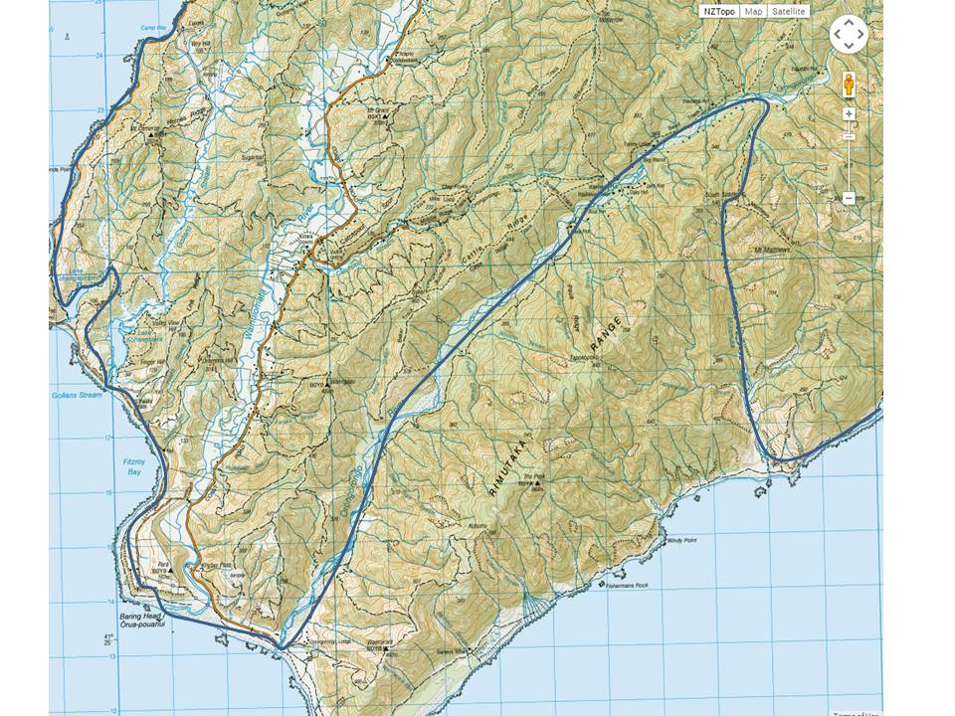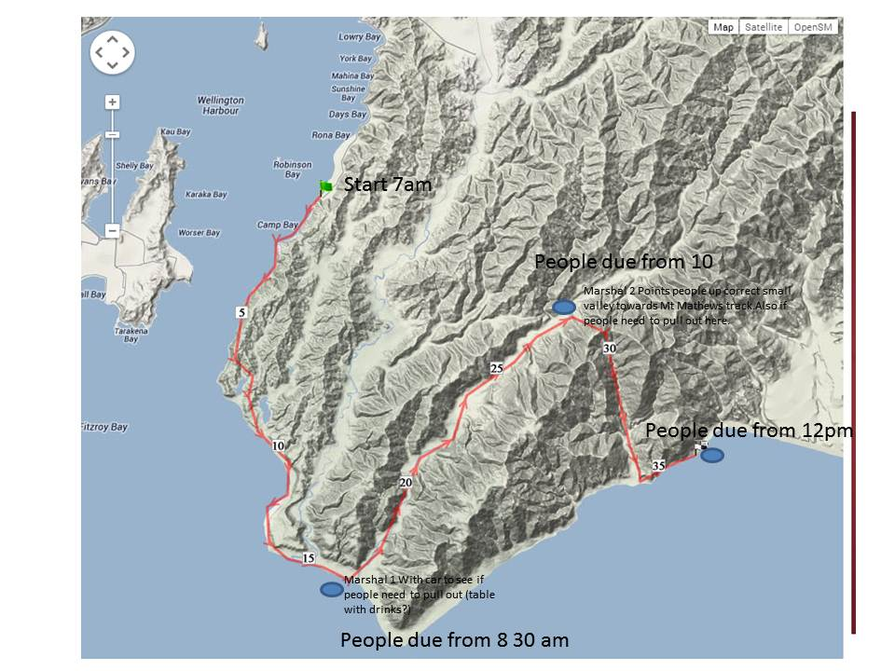

Day 2 Marshal Map

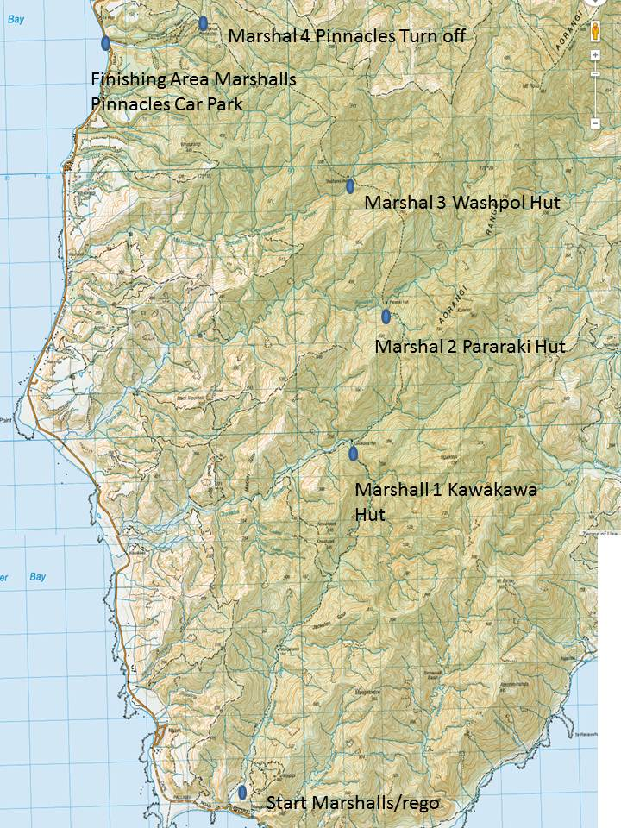

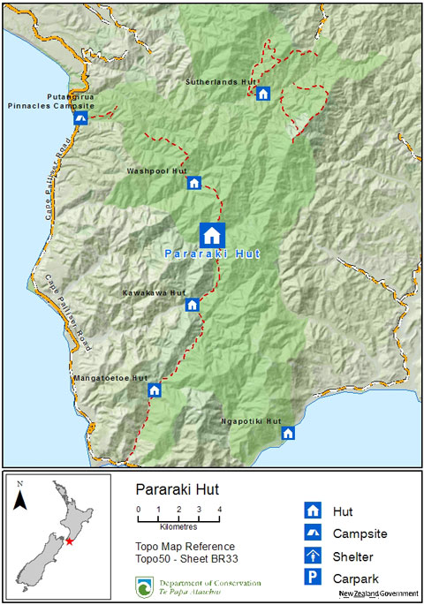

Day 3 Marshal Map

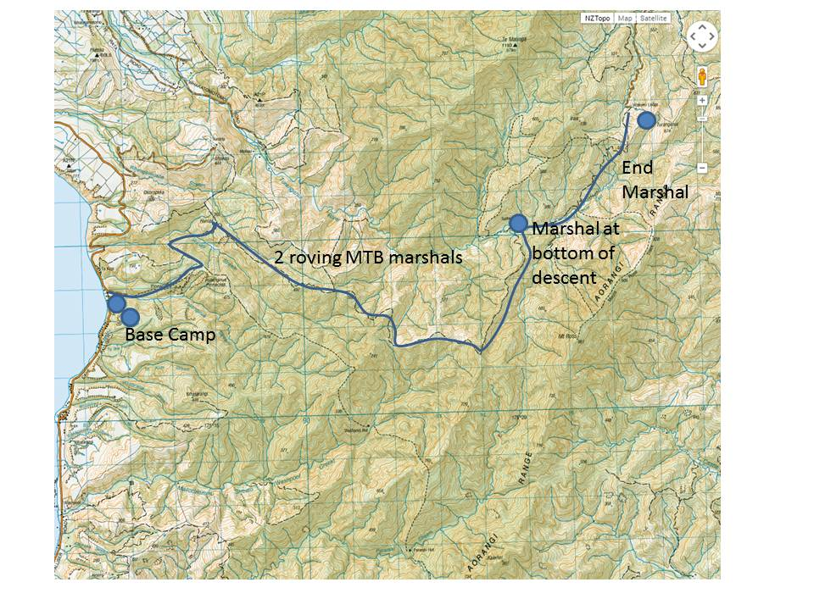

# Race Terrain

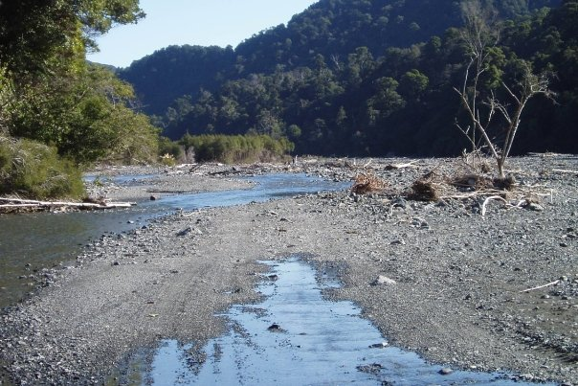

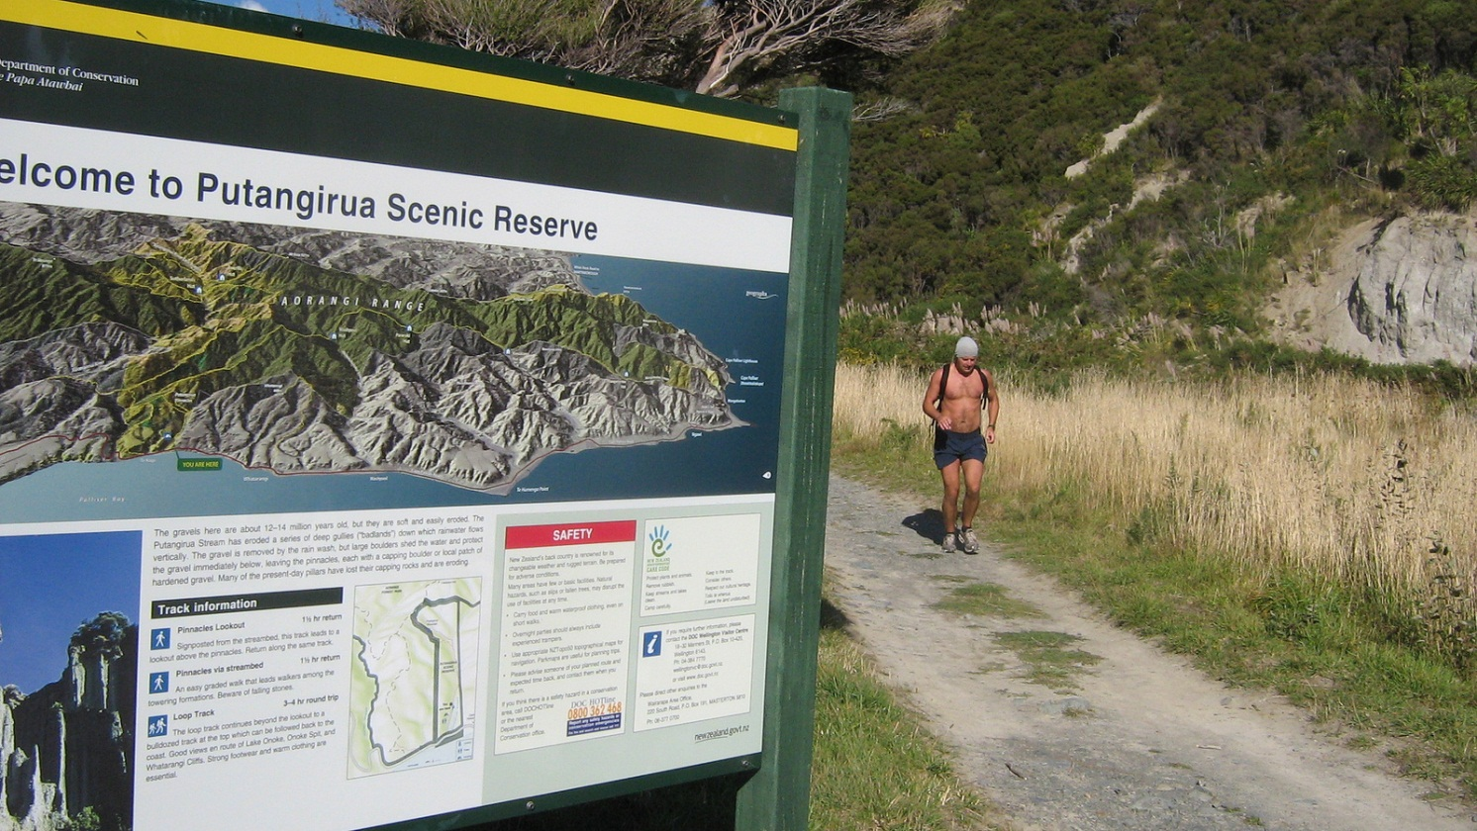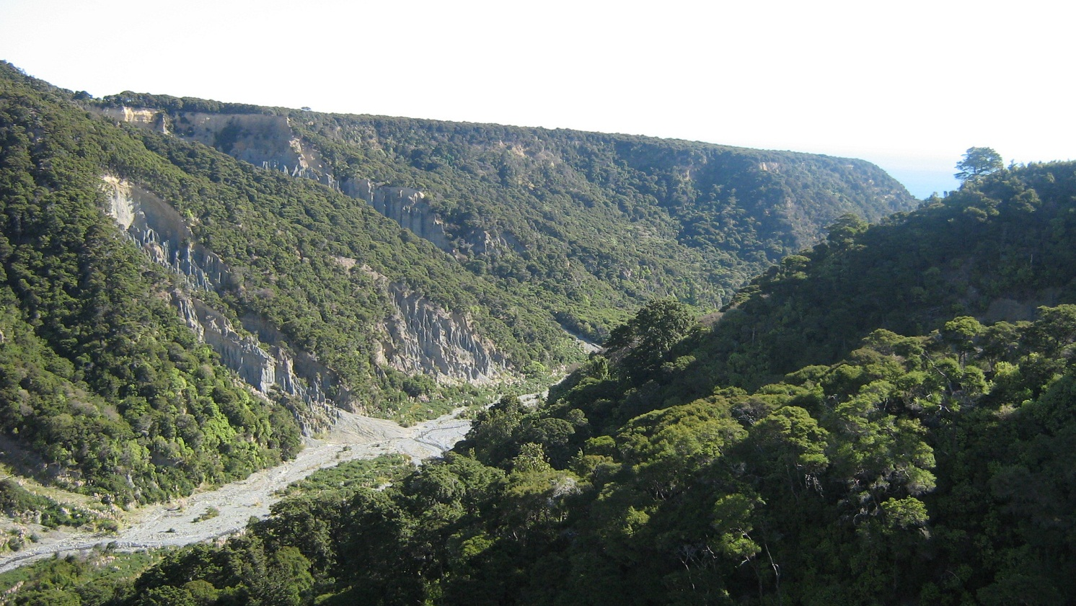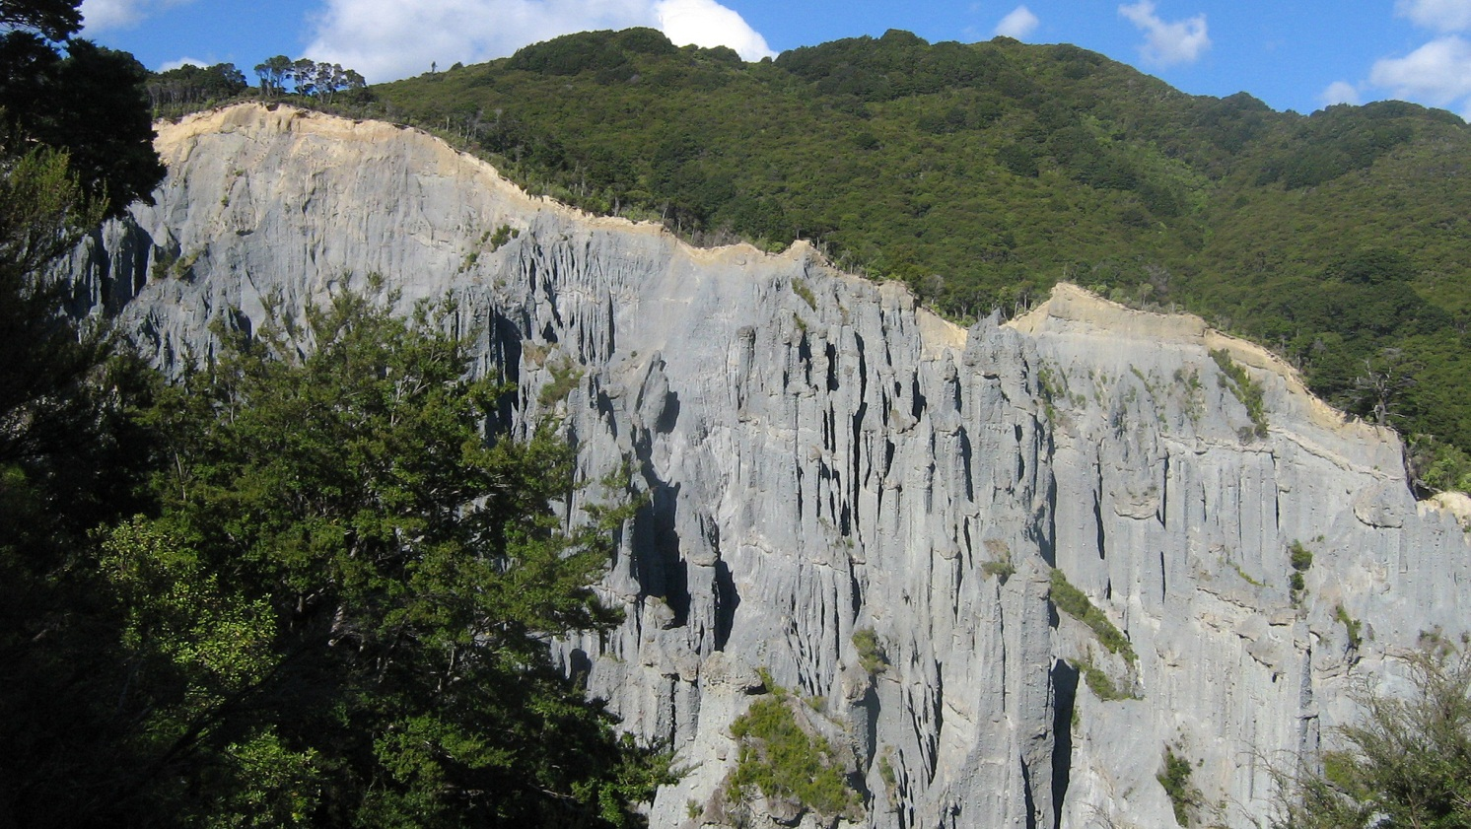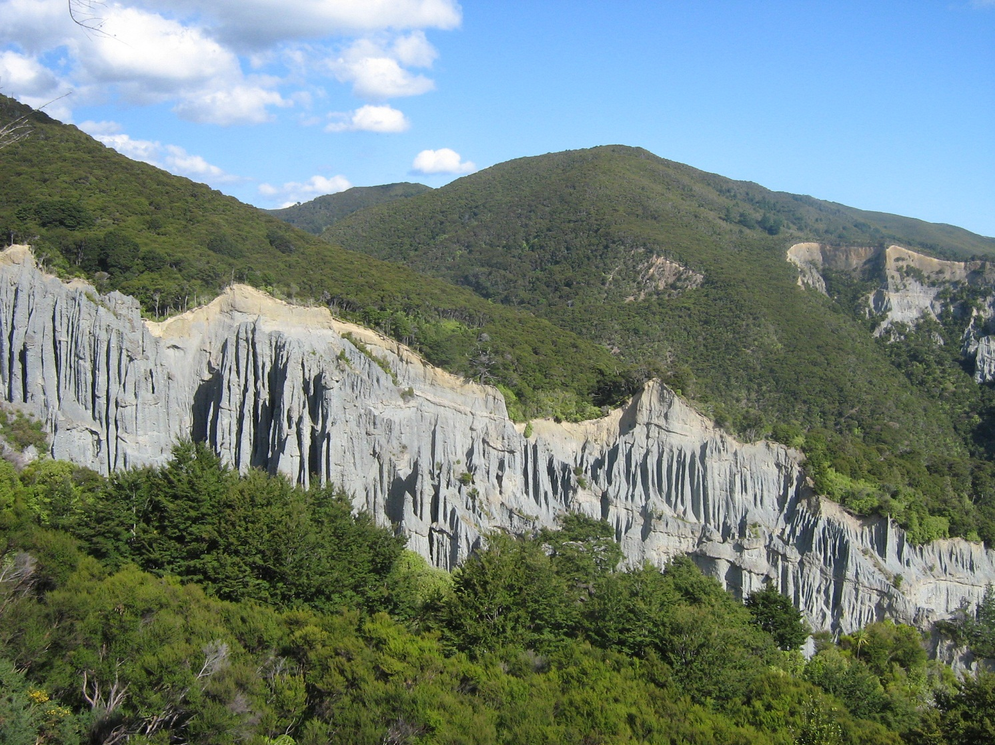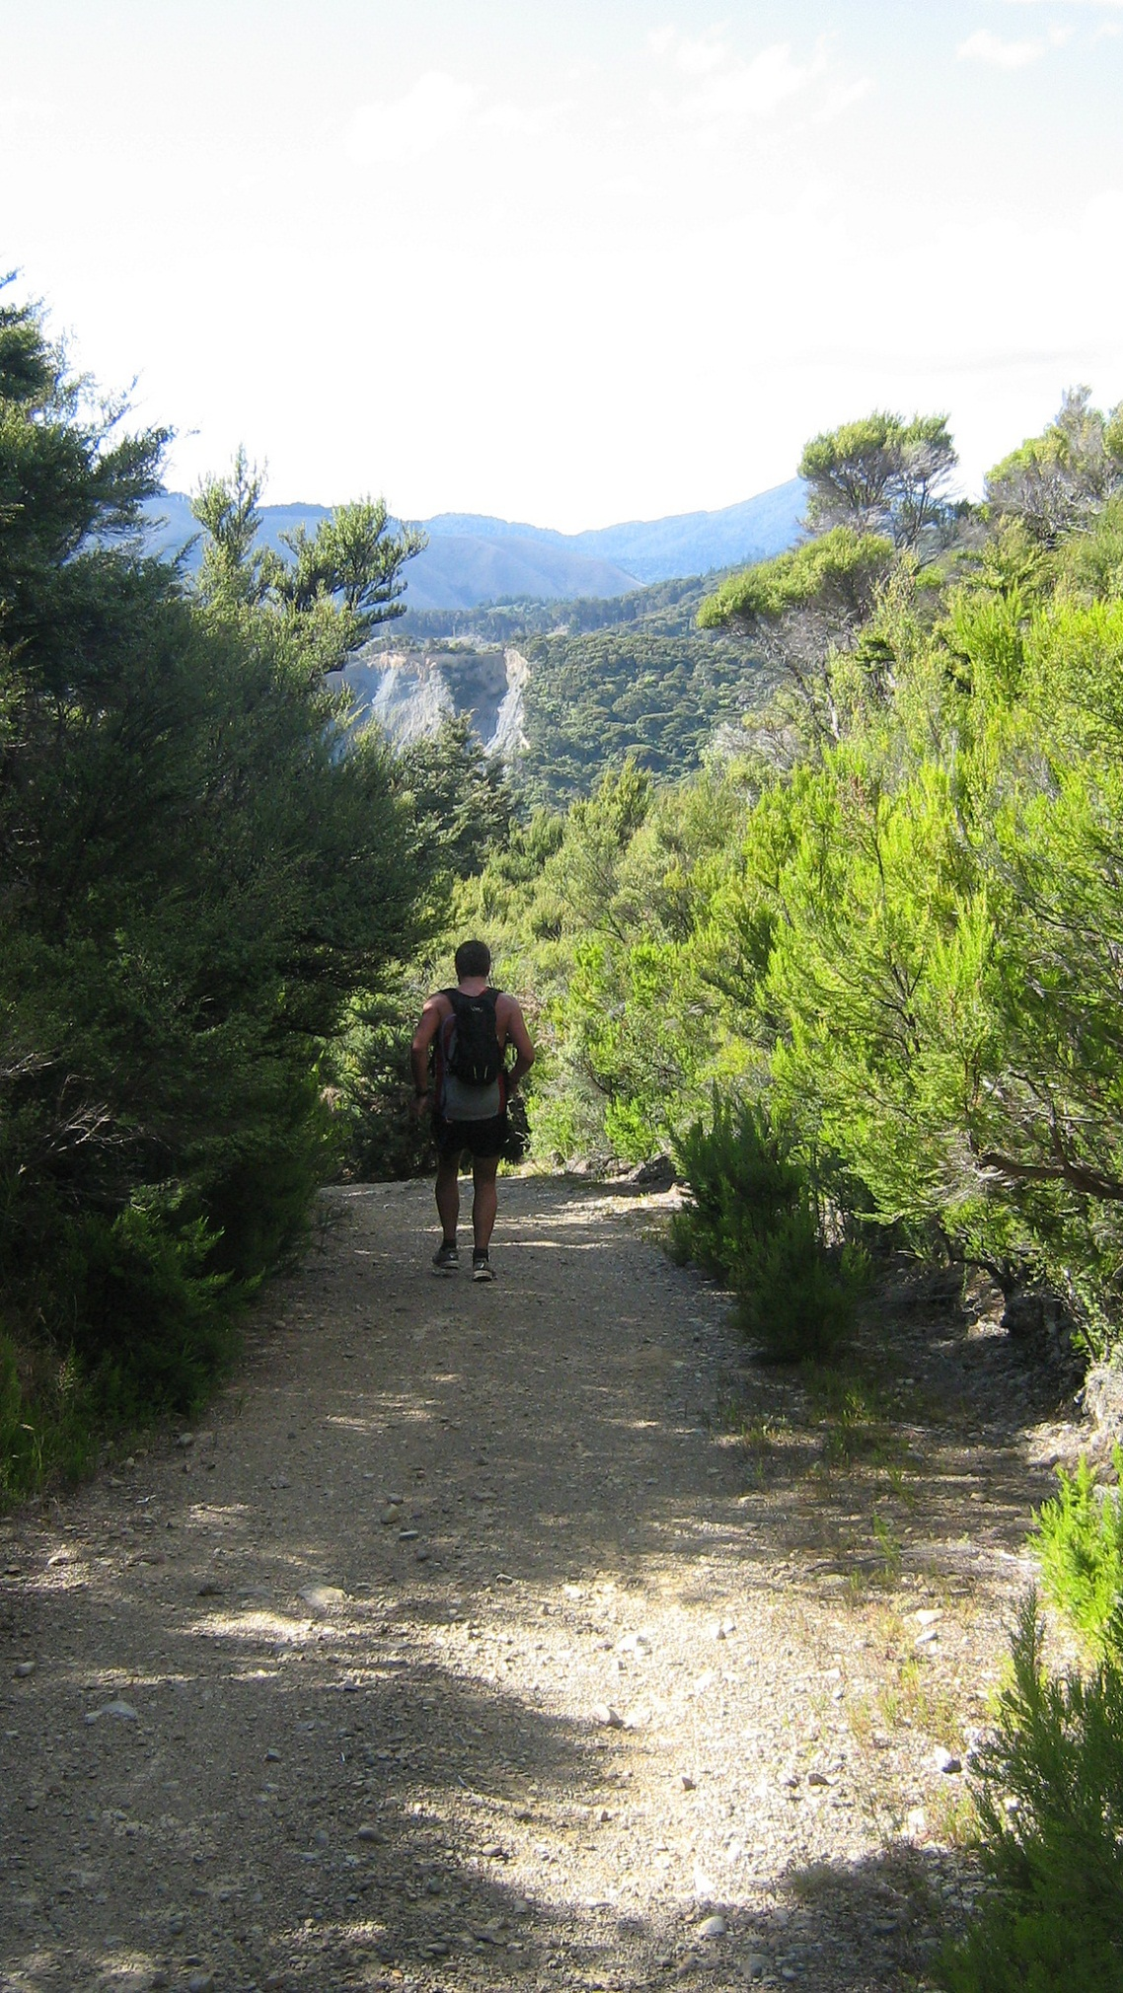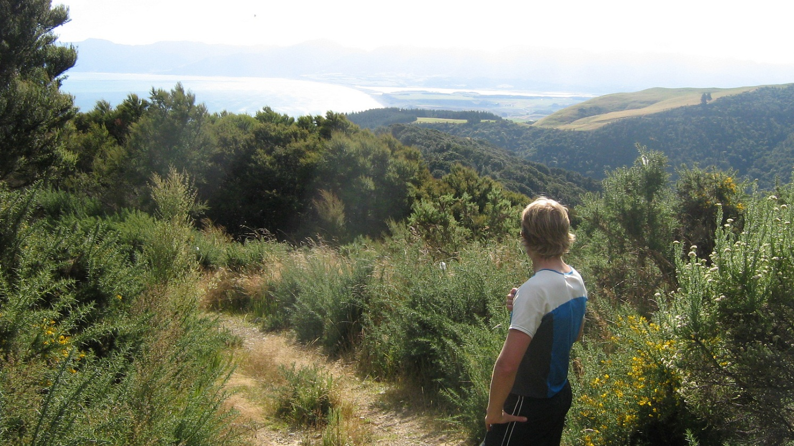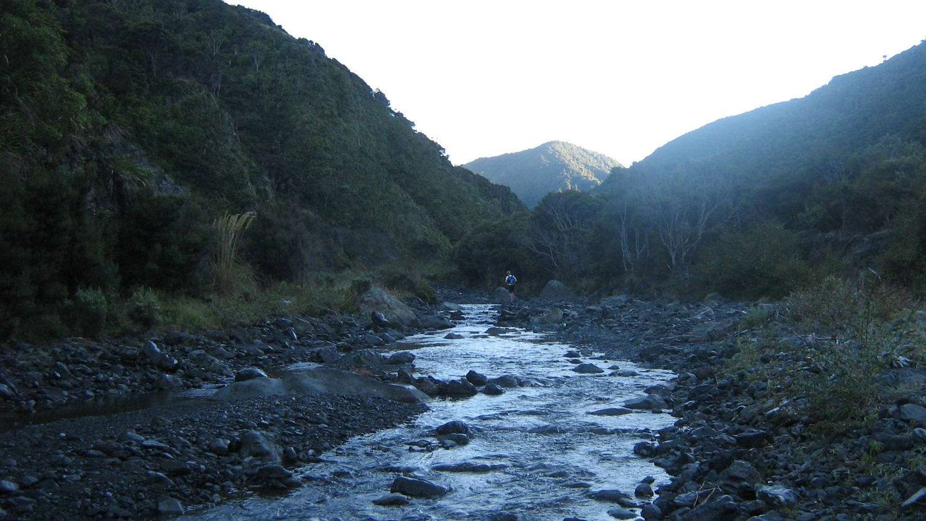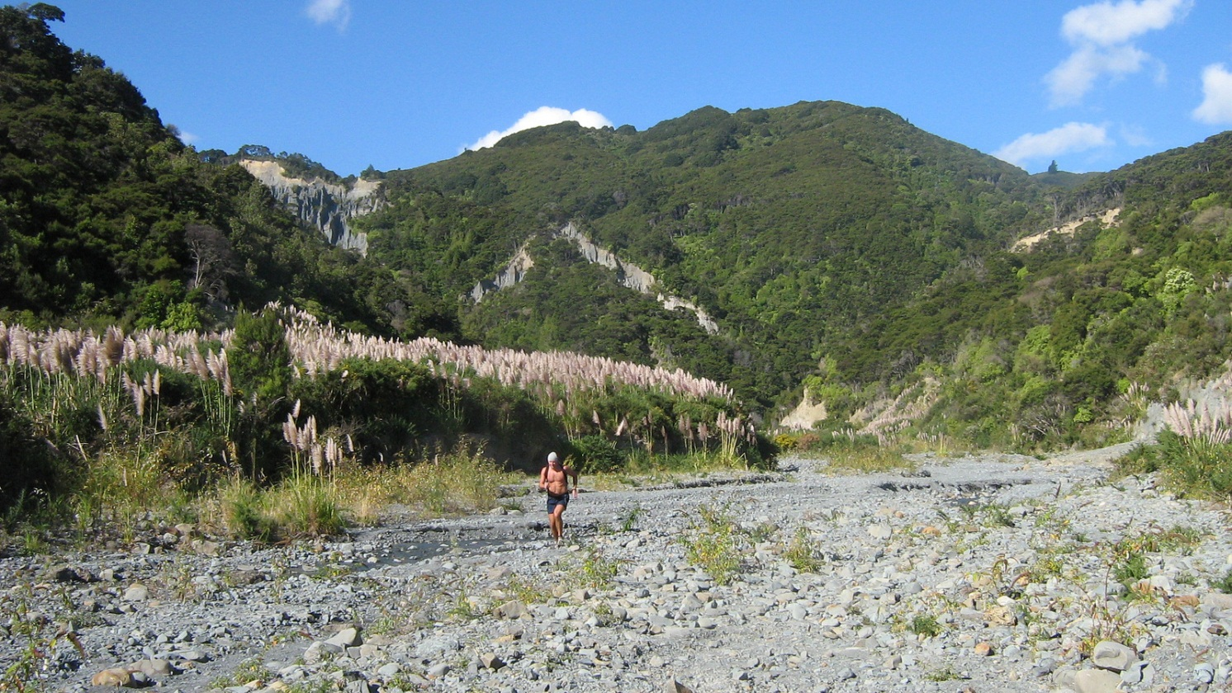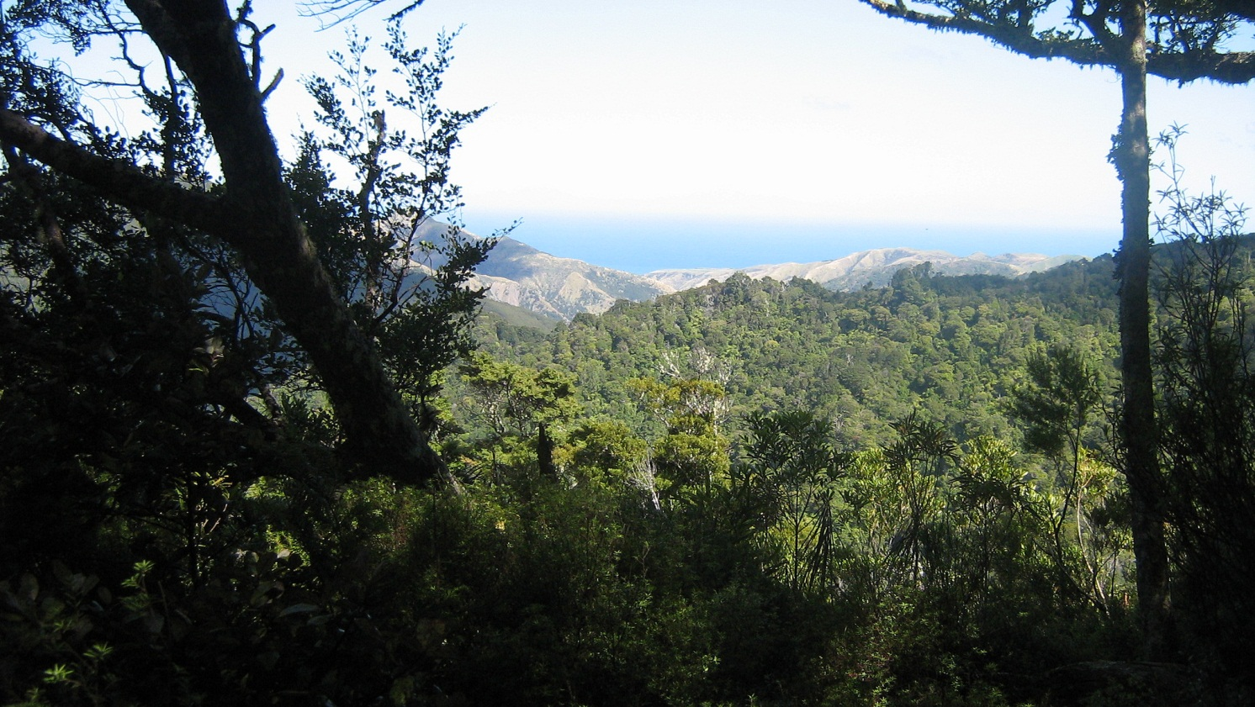

Elevation Map Day 1

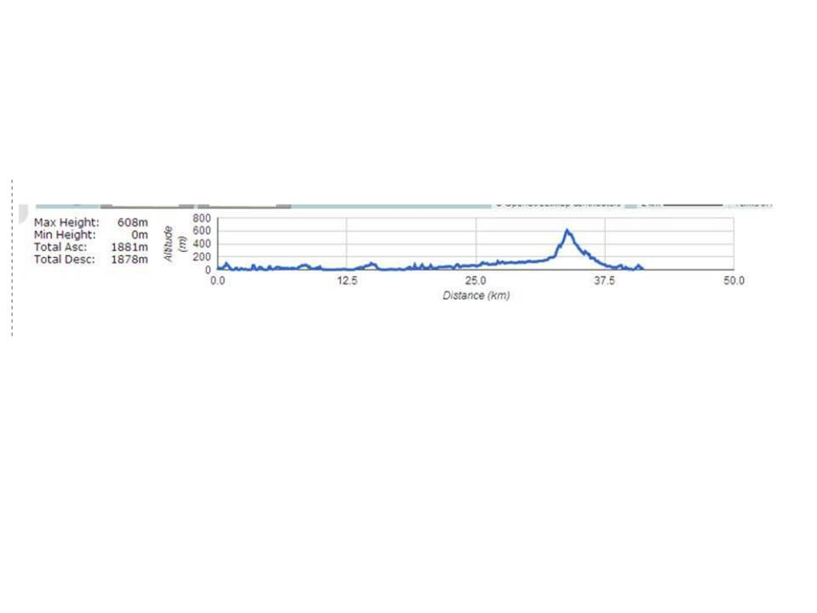

Elevation map of Day 2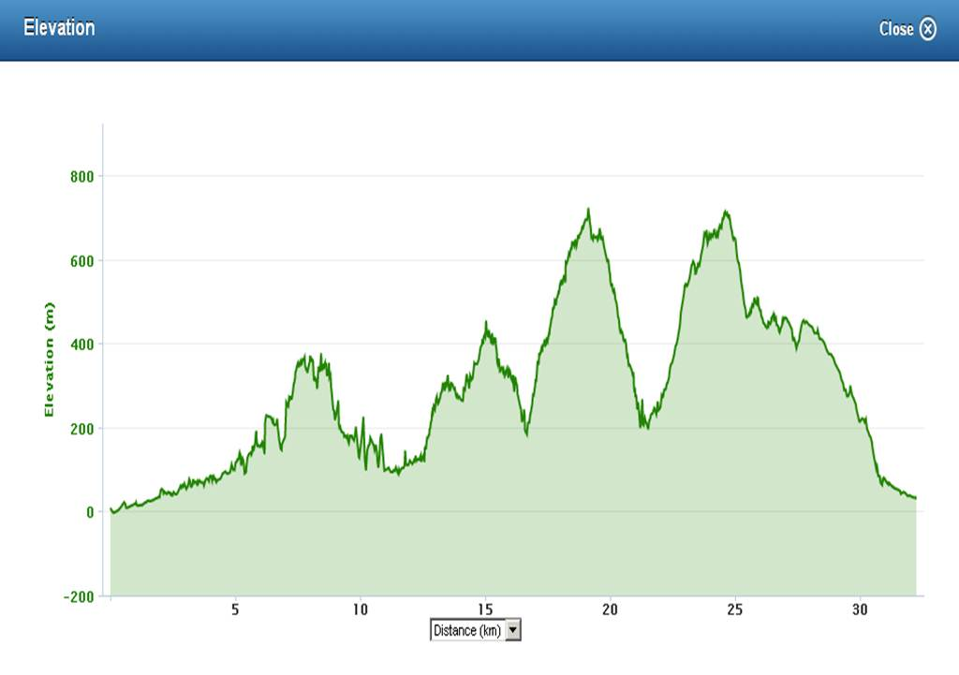

Elevation map of Day 3

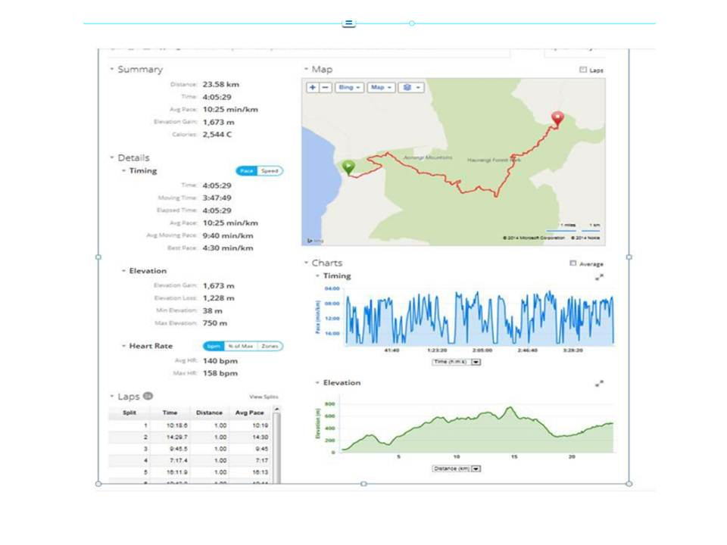

# Entry Form and Disclaimer

**Aorangi Undulator and Aorangi 100 Entry Form**

Contact Details

Name:

Address:

Phone Number:

Email Address:

Emergency Contact

Name:

Phone Number:

Relationship:

Disclaimer/waiver

I declare that:

1. I understand that this race is not for the weak, and that no sign of weakness will be tolerated.
2. I acknowledge that there are risks involved with off road running and fully realise the dangers of participating in an event such as this and fully assume the risks associated with such participation and my wellbeing during the event.
3. I understand and agree that situations may arise during the event, which may be beyond the immediate control of officials or organisers, and I must continually participate in a manner that does not endanger either myself or others.
4. Neither the organisers, the sponsors nor other parties associated with the event shall have any responsibility, financial or otherwise, for any risk incident that might arise, whether or not by negligence, from any direct or indirect loss, injury or death**\*** that might be sustained by me or any other party directly or indirectly associated with me, from my intended or actual participation in the event or its related activities.
5. I authorise my name, voice, picture and information on this entry form to be used without payment to me in any broadcast, telecast, promotion, advertising, or any other way pursuant to the Privacy Act 1993.
6. I agree to comply with the rules, regulations and event instructions of the Aorangi Undulator.
7. I undertake not to hold the event organisers or event sponsors liable for any damage in respect of any claims in relation to events/functions being held as part of or in conjunction with the Aorangi Undulator.

Signed _______________________________________________ Date _____________________